**HOSPITAL MANAGEMENT SYSTEM**

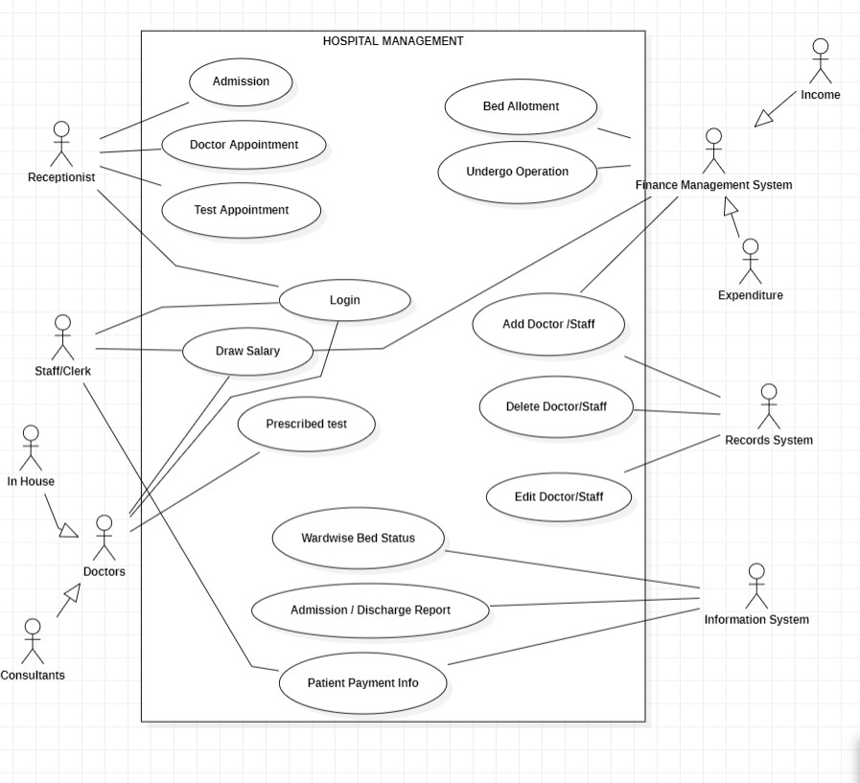***USE-CASE DIAGRAM:***

***SEQUENCE DIAGRAM:***

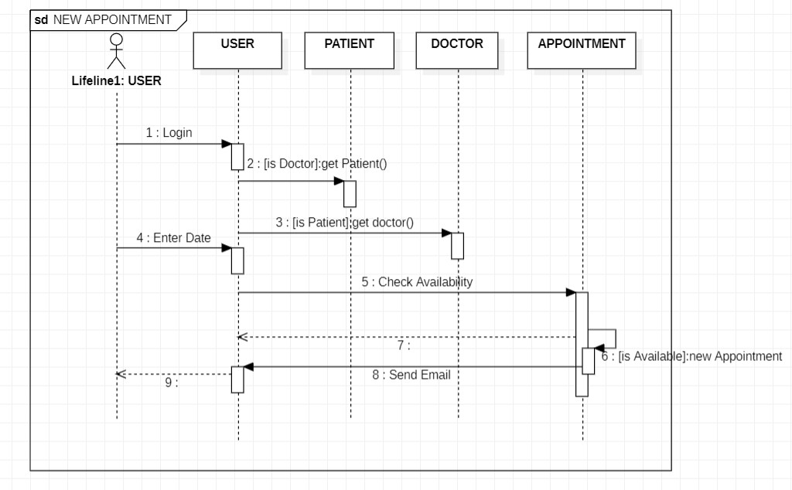

***COLLOBARATION DIAGRAM:***

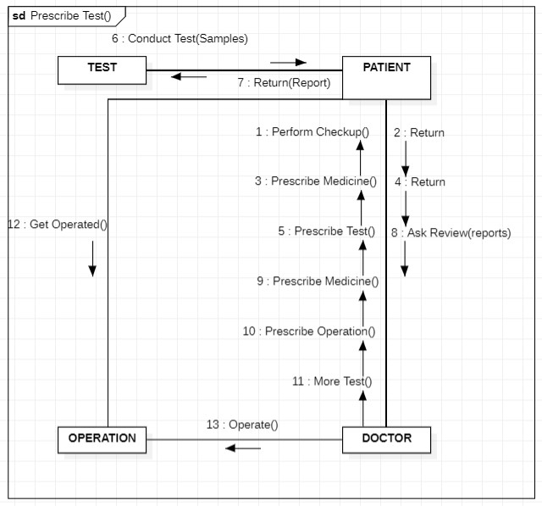

**DOCTOR CLASS**

#ifndef _DOCTOR_H

#define _DOCTOR_H

#include "HospitalStaff.h"

class Doctor: public HospitalStaff {

private:

    string fieldOfSpecialization;

    bool appointmentStatus;

void Getinfo();

void GetAppointment();

};

#endif //_DOCTOR_H

**HOSPITAL CLASS**

#ifndef _HOSPITAL_H

#define _HOSPITAL_H

class Hospital {

public:

    string HospitalName;

void SeeStaff();

void AddNewStaff();

void Operation1();

    class Class1 {

    };

private:

    List<HospitalStaff> listOfStaff;

};

#endif //_HOSPITAL_H

**HOSPITALSTAFF CLASS**

#ifndef _HOSPITALSTAFF_H

#define _HOSPITALSTAFF_H

class HospitalStaff {

public:

    string FullName;

void Getinfo();

void ChangeNumberOfPatients();

/**

 * @param Patient

 */

void AddNewPatient(void Patient);

void GetAllPatients();

void Operation1();

private:

    void staffId;

    int numberOfPatients;

    List<Patient> listOfPatients;

};

#endif //_HOSPITALSTAFF_H

**NURSE CLASS**

#ifndef _NURSE_H

#define _NURSE_H

#include "HospitalStaff.h"

class Nurse: public HospitalStaff {

public:

void Getinfo();

/**

 * @param Doctor

 */

void AssignToDoctor(void Doctor);

private:

    Doctor headDoctor;

};

#endif //_NURSE_H

**PATIENT CLASS**

#ifndef _PATIENT_H

#define _PATIENT_H

class Patient {

public:

string GetFullName();

private:

    int patientId;

    string firstName;

    string lastName;

    string phoneNumber;

    string address;

};

#endif //_PATIENT_H

**RECORD CLASS**

#ifndef _RECORD_H

#define _RECORD_H

class Record {

public:

void GetPatientInfo();

void ChangeDiagnosis();

/**

 * @param Doctor

 */

void AssignFamilyDoctor(void Doctor);

void Operation1();

private:

    int recordId;

    string diagnosis;

    int age;

    Doctor familyDoctor;

};

#endif //_RECORD_H